*11/9/2021 -- didn’t have preserved lemon, used a regular lemon. Make sure to use lemon zest and decrease the yogurt so lemon comes through. Used regular old eggplant, which was great. Sheet pan on parchment paper, which was perfect. Good char, good taste. Used half a large onion, needed more. Left out tomato paste, that was a mistake. Had too many tomatoes. Need more oomph, I think that was the tomato paste.

*8/2/21 -- didn’t have preserved lemon, used a regular lemon. Make sure to use lemon zest and decrease the yogurt so lemon comes through. Used regular old eggplant, which was great. Next time make larger than 3cm pieces so you get a little eggplant left inside instead of char. Onion seems like a lot (used 2 mediums) but was actually perfect.

https://www.theguardian.com/food/2018/aug/18/yotam-ottolenghi-tomato-recipes

Whether tinned or as paste, tomatoes add robust flavour to this delicious duo
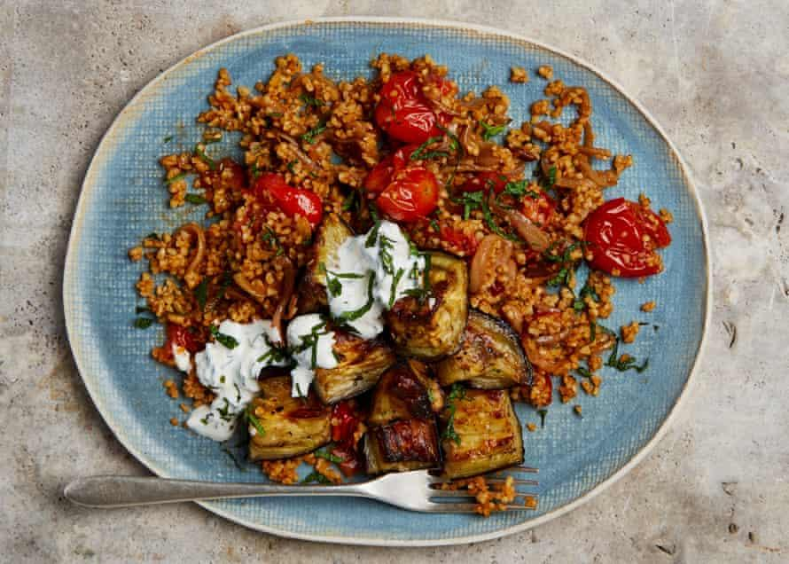

Just look at all the pantry staples made with tomatoes – tinned, paste, passata, sun-dried and more – each a variation on the bright-red theme. It’s that desire to capture summer in a jar, tin or tube that provides cooks with some of their snappiest tools for layering tomatoey flavours. Yes, there’s nothing quite as glorious as a perfectly ripe, raw tomato, but in cooking, adding all its derivatives into the mix opens up a world of creatively fine-tuning sweetness, acidity and freshness.

Bulgur with tomato, aubergine and preserved lemon yoghurt (pictured above)
This is made of three components – roasted aubergine, bulgur with tomato, and yoghurt sauce – all of which I adore on their own. Together, however, they make a truly memorable vegetarian main, which can easily be turned vegan by using a dairy-free yoghurt. It also works as a side dish, in which case these quantities will serve six to eight.
Prep 15 min
Cook 45 min
Serves 4 as a main
2 large aubergines (500g net weight), cut into 3cm chunks
100ml olive oil
Salt and black pepper
2 onions, peeled and finely sliced
3 garlic cloves, peeled and crushed
1 tsp ground allspice
400g cherry tomatoes
1 tbsp tomato paste
250g bulgur wheat
200g Greek-style yoghurt
1 small preserved lemon, pips discarded, skin and flesh finely chopped
10g mint leaves (about 1 tbsp) finely shredded
Heat the oven to 220C/425F/gas 7. Put the aubergine in a large bowl with four tablespoons of oil, half a teaspoon of salt and a good grind of pepper. Mix, then spread out on a large oven tray lined with greaseproof paper and roast for 30-35 minutes, stirring once halfway, until the aubergines are caramelised and soft. Take out of the oven and leave to cool.
Meanwhile, put three tablespoons of oil in a large saute pan for which you have a lid and heat on a medium-high flame. Once hot, fry the onion for eight minutes, stirring a few times, until caramelised and soft. Add the garlic and allspice, fry for a minute, stirring continuously, until the garlic is aromatic and starting to brown, then add the cherry tomatoes, mashing them with a potato masher to break them up. Stir in the tomato paste, 400ml water and a teaspoon of salt, bring to a boil, turn down the heat to medium-low, cover and cook for 12 minutes. Add the bulgur, stirring it in so it’s completely coated, then turn off the heat and set aside for 20 minutes, so the bulgur can absorb all the liquid.
In a medium bowl, mix the yoghurt with the preserved lemon, half the mint and an eighth of a teaspoon of salt.
Divide the bulgur between four plates and serve with the yoghurt and aubergine alongside and a sprinkling of the remaining mint.

